Andrey Chirikov, Brady Kreil, Gus Hawley,

Harry Zhou, Mikhail Ignatyev, Stephanie Monagan

**OPTICAL MODULE**

**ASSEMBLY INSTRUCTIONS**

UBC Manufacturing Engineering

Capstone Project 2024/2025

1. Introduction 1

2. Design Overview 1

3. BOM 2

4. Machined Parts 2

4.1 Frame 2

4.2 Plates 3

5. 3D Printed Parts 4

5.1 Overview 4

5.2 Recommended Settings 5

5.3 Camera Carriage 5

5.4 Mirrored Brackets 6

6. Assembly 6

6.1 Frame Assembly 6

6.2 Camera Carriage 7

6.3 Belt Assembly 8

6.4 Platform Assembly 10

6.5 Linear Rail Alignment 11

6.6 Z Motor and Ball Screw Alignment 12

6.7 Electrical Assembly 12

6.8 Overview 12

6.9 E-STOP 13

6.10 Buck Converters 13

7. Software Setup 14

7.1 Raspberry Pi Settings 14

7.2 Networking 14

7.3 Windows PC 16

7.3.1 Ethernet 16

7.3.2 Folder Directories 16

7.3.3 Fiji (ImageJ) 16

Appendix 19

A.1 – Full Parts List 19

A.2 – List of Fasteners per Part 23

A.3 – List of Machined Parts 26

A.4 – Assembly List - Electronics 27

A.5 – BOM - Electronics 29

# 1. Introduction

This document is intended to go over how to assemble the optical module from scratch. The optical module is an automated microscope, designed to be integrated in a self-driving lab. Many components and information will be stored on our GitHub and referenced throughout the document:  
<https://github.com/ManuCapstone1/OpticalModule/tree/main>

# 2. Design Overview

This section provides an overview of the final design. The entire assembly is mounted on 20x20 aluminum extrusions, forming a rigid structural frame. The sample platform is a breadboard, allowing flexible placement of the sample at any position. The platform assembly is supported by two trolleys running along rails, enhancing the rigidity of the structure. It is connected to a ball screw mechanism actuated by a DC motor to ensure precise movement along the Z-axis.

The optical module moves in the XY plane and is mounted on a trolley rail system, similar to the Z-axis setup. However, its movement is controlled by a CoreXY motion system, which uses belts and DC motors for efficient and precise positioning. The CAD model shown in Figure 1 shows the complete design, excluding belts and fasteners. A detailed list of fasteners and their connection points is provided in Appendix A.2.

*Figure 1: Front and back view of the main assembly of the project*

# 3. BOM

The full list of all the needed parts and tools are found in appendix A.1 – Full Parts List. Parts lists for fasteners and machined parts are also in appendix A. For a more detailed and organized view, an excel spreadsheet is in the GitHub repository in [OpticalModule/Documentation/Github_BOM](https://github.com/ManuCapstone1/OpticalModule/blob/main/Documentation/Github%20BOM.xlsx).

# 4. Machined Parts

## 4.1 Frame

The extrusions used for the frame of the module need to be extremely precise and have a flat surface on each end to ensure a square fit between all of the extrusions.

The recommended cutting procedure is as follows:

1. Measure the required extrusion length, adding 5 mm to the specified length. Mark the measurement on the extrusion using a marker. Measure from the factory cut end, when possible, to ensure better cut surface quality.
2. Cut the extrusion using a bandsaw.
3. Set up a milling machine for cutting the extrusions. Secure an adjustable end stop to serve as a reference point for all extrusion pieces. Keep the end stop fixed for pieces of the same length, but adjust it as needed for other lengths.
4. Place the extrusion in a vise, press it against the end stop, and tighten the vise securely.
5. Load an edge finder tool, turn on the spindle, and carefully move the tool against the extrusion’s end-stop edge from the side until it shifts—this marks the zero point, factoring in the edge finder’s radius.
6. Raise the edge finder above the extrusion piece’s edge and verify its position. It should match the radius of the edge finder. If correct, zero the coordinates again—this is the final zero point.
7. Replace the edge finder with a milling tool. For 20x20 extrusions, a 1" tool is recommended. Calculate the final milling position as the desired length plus the tool’s radius.
8. Mill the free end of the extrusion using 0.5 mm passes, finishing with a down milling cut for a better surface finish. Verify the final length, ensuring it falls within the 0.1 mm tolerance.

## 4.2 Plates

The recommended machining procedures for the enclosure backplate, platform baseplate and the Breadboard Platform are described below. For dimensions and other information, reference Appendix A.3 – List of Machined Parts.

**Enclosure Backplate**

1. Select a metal sheet of the specified thickness. Using a marker, outline the specified length and width according to the drawing.
2. Cut the sheet to size using a shear cutter. For better accuracy, cut slightly beyond the marked dimensions to allow for final adjustments by grinding if needed.
3. Place the sheet on a flat granite surface and use a height gauge to scribe lines indicating the specified hole positions.
4. At each intersection of the scribed lines, use a center punch and hammer to create small dents. This will help guide the drill bit accurately.
5. Prepare M2.5, M3, and M5 drill bits for use with a drill press. Secure the sheet face-up in a vise, ensuring it is tightly clamped.
6. Load the first drill bit into the drill press. Align it with a punched dent and lower it slightly to confirm proper positioning. Adjust the vise if necessary.
   1. Drill through each marked hole, following the specified locations.
   2. Repeat step 6 for each drill bit size.
7. Use a deburring tool to remove any burrs from the back side of the plate.

**Base plate**

The base plate was fabricated using a waterjet cutter. A correctly sized metal plate was positioned in the machine, and the DXF file containing the final shape was uploaded to the cutter’s computer. The plate was then cut according to standard waterjet cutting procedures.

**Breadboard Platform**

1. Place the original Breadboard Platform on a flat granite surface. Use a height gauge to scribe lines marking the specified hole positions.
2. At each intersection of the scribed lines, use a center punch and hammer to create small dents to guide the drill bit.
3. Secure the Breadboard Plate firmly in a vise.
4. Select an M6 drill bit suitable for use with a drill press. Load it into the drill press and lower it onto a dent to verify proper alignment. Adjust the vise if necessary.
5. Drill through each marked hole.
6. Use a deburring tool to remove burrs from the opposite side of the plate.

# 5. 3D Printed Parts

## 5.1 Overview

All the .STL files for the parts that need to be printed can be found on the GitHub under [OpticalModule/CAD/STL Files/.](https://github.com/ManuCapstone1/OpticalModule/tree/main/CAD/STL%20Files) To see a list of the parts go to the “3D Printed” category in appendix A.1 – Full Parts List. Furthermore, a list of all the fasteners corresponding to each part is in appendix A. – List of Fasteners per Part.

## 5.2 Recommended Settings

Below are the settings and parameters the team used in the slicer to print the 3D printed parts with a FDM printer. The parts were printed with the intention of having good structural integrity and rigidity to prolong the lifespan and reduce vibrations. These settings are *suggestions*, and users are at liberty to modify them as needed.

One exception to these settings are the jigs for the linear rails. Since they are not used in the final product, nor structurally, standard/weaker settings can be used instead.

Table 1: Recommended printer settings for 3D printed parts.

|  |  |  |
| --- | --- | --- |
| Parameter | Setting/Parameter | Notes |
| Material | ABS, PLA, PLA +, PETG | Stronger materials will work as well but are not needed. |
| Resolution | 0.02 mm |  |
| Infill | ~50% |  |
| Infill Pattern | Cubic | Good for strength in all directions. |
| Supports | >45 degrees |  |
| Shell Thickness | 1.2 mm in both directions. |  |

## 5.3 Camera Carriage

The STL file “EnclosureBase” is the main body of the camera carriage. Orient the part as shown below in gure 2, as it ensures a nice outer finish and minimal shifting errors and cracking. When the print is complete, removing the supports is difficult. If needed, use pliers, a Dremel and/or similar tools.

Figure : Orientation of how the "EnclosureBase" STL file should be placed on the slicer.

## 5.4 Mirrored Brackets

Two STL files “XY Motor Mount” and “Z Carriage” need two parts each, one as is, and the other mirrored. Use the slicer to mirror one of the parts. Figure and Figure 4 show how the parts should be mirrored. Note that the parts in the figures were placed to show how the parts should be mirrored, *not* how the parts should be oriented for printing.

Figure 3: View of how "XY Motor Mount" STL files should be mirrored in the slicer.

Figure : View of how "Z Carriage" STL File should be mirrored in the slicer.

# 6. Assembly

## 6.1 Frame Assembly

1. To assemble the frame, start by constructing the sides. Lay two 465 mm extrusions on a flat surface and position three 370 mm extrusions perpendicularly between them.
2. Secure the 370 mm pieces to one of the 465 mm extrusions using M5x10 fasteners and M5 T-nuts (detailed list of fasteners in Appendix A.2), then repeat for the other 465 mm extrusion.
3. Check squareness by standing the subassembly vertically and using a bubble gauge to verify perpendicularity. Adjust the brackets as needed to center the bubble.
4. Next, lay assembled side flat and attach four 370 mm extrusions vertically using M5x10 fasteners and M5 T-nuts, ensuring proper alignment.
5. Attach four brackets—two on each side—to the 395 mm extrusion, then slide it into place parallel to the 465 mm extrusions.
6. Secure the second assembled side to complete the frame, then verify squareness again with a bubble gauge, adjusting as necessary.
7. Then, install the 3D-printed top corner brackets and T-brackets using M5x10 fasteners and M5 T-nuts.
8. Add X limit switch mount by attaching limit switch to the mount using M3x16 fasteners and M3 nuts and attaching the mount to the extrusion using M5x10 fasteners and M5 T-nuts.
9. Finally, install linear rails by using M3x8 fasteners and M3 T-nuts and following the linear rail alignment procedure outlined in a section below.

## 6.2 Camera Carriage

1. To assemble the Camera Carriage, start with the Enclosure Backplate by attaching the metal plate to the 3D-printed Enclosure Base using four M3x4 fasteners and M3 Hex Nuts.
2. Before proceeding further, complete the Belt Assembly system (see below). Next, screw the threaded Camera into the Lens and mount them to the Enclosure Base using a 1/4-20 fastener, placing two 1/4" Washers between the camera and the enclosure.
3. Secure the Lens by positioning the Ring Light at the bottom of the Enclosure Base and fastening it with the included M4 Thumb screws, which will later allow for perpendicularity adjustments.
4. Mount the Raspberry Pi to the bottom of the Upper Enclosure Cover using four M2.5x16 fasteners and M2.5 Hex Nuts, ensuring its external ports face outward.
5. Finally, attach the Upper Enclosure Cover to the Enclosure Base and secure them with the Front Enclosure Cover. Refer to Figure 5 for an exploded view of these steps and Appendix A.2 for a detailed list of fasteners.

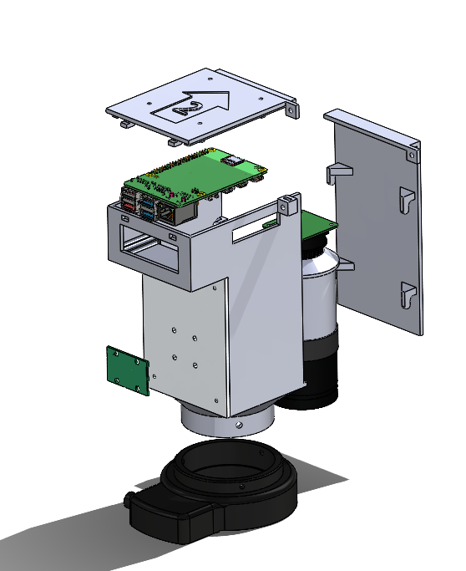

Figure 5: Camera carriage assembly; exploded view

## 6.3 Belt Assembly

The motion in the X-Y plane is controlled using a CoreXY belt configuration. In this motion strategy, the two motors work together to move the carriage in both the X and Y directions. Consequently, the left and right motors are designated as Motor A and Motor B, respectively. Each motor is associated with its own belt, which runs from one side of the carriage assembly, through a set of idlers, around the motor, and back to the other side of the carriage. In this CoreXY application, the A and B loops are stacked vertically in the Z direction, with the B loop always above the A loop. The ends of both loops are clamped between the aluminum backplate of the carriage enclosure and the belt adapter, which has four sets of teeth to mesh with the four belt ends. More information about the CoreXY theory and governing equation can be found at corexy.com.

The assembly of the X-Y belt system is as follows (refer to Appendix A.2 for the detailed fastener list):

1. Begin by assembling the Y carriage, which includes the X-axis gantry aluminum extrusion and the left and right brackets.
   1. Attach the linear rail and trolley to the front face of the aluminum extrusion using M3x8 fasteners and T-nuts.
   2. Use M5x40 fasteners and hex nuts to attach the upper and lower halves of the brackets around the extrusion.
   3. Install the idlers, with the front idler consisting of two smooth bearings and the back idler a toothed idler. They are installed using M5x40 fasteners with a washer above and below.
   4. Attach the Y carriage to the two Y trolleys using four M3x12&x30 fasteners.
2. Assemble the XY motor mounts with the stepper motors using M3x8 fasteners and attach the pulleys to the stepper motors.
3. Install the motor mounts on the front two vertical extrusions using M5x10 fasteners. Pay attention to the height of the pulleys. Pulley B should be aligned with the upper set of idlers, while Pulley A should be aligned with the lower set of idlers. This can be done roughly at first and then adjusted.
4. Assemble idler mounts A and B. Each idler mount contains two toothed idlers and three washers on an M5x40 fastener. The limit switch is installed using M3x16 fasteners.
5. Install the idler mounts on the rear left and right vertical extrusions. Idler mount A includes a mounting point for the Y limit switch and should be installed on the left side (closest to Motor A).
6. Assemble, but do not install, the belt tensioner. The belt tensioner includes four smooth bearings forming two smooth idlers. An M5x45 fastener runs through the bearings, and a hex nut is used between the bearings to align them.
7. Install belt loop A. Belt A runs from the lower left slot on the belt adapter, with the teeth facing the trolley, around the smooth idler on the left Y carriage, around Pulley A, around the lower idler on idler mount A, around the lower idler on idler mount B, around the toothed pulley on the right Y carriage, and to the lower right slot on the belt adapter.
8. Install belt loop B. Belt loop B follows the opposite path using the upper set of idlers and belt adapter slots.
9. Clamp the belts by installing the carriage enclosure. Start by temporarily taping the belt clamp to the X-axis trolley. Then, while holding all four belt ends in position on the belt adapter, use four M3x8 fasteners to attach the carriage enclosure to the trolley and belt adapter, clamping everything together.
10. Install the belt tensioner on the back center vertical extrusion using an M5x10 fastener and place the belts in position.

## 6.4 Platform Assembly

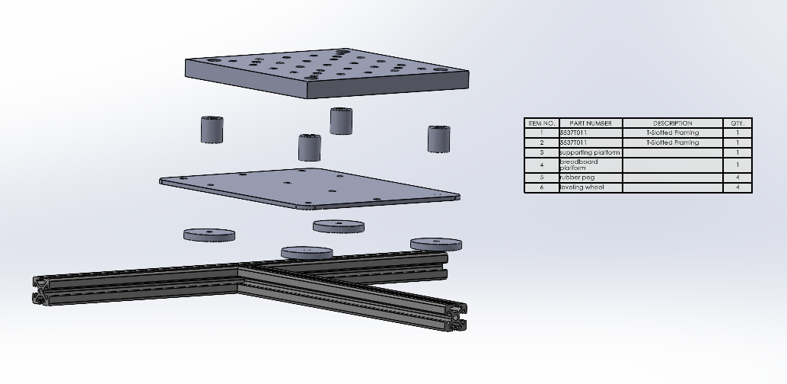

Figure 6: Exploded view of the platform and relevant bill of materials

1. First, secure the three Z-axis linear rails to the frame using five M3x8 fasteners and M3 T-Nuts (see Linear Rail Alignment).
2. Attach the Z Carriage Brackets to the trolleys on the two front linear rails with four M3x12 fasteners each.
3. Next, mount a 370mm aluminum extrusion to the Z Carriage Brackets using two M5x10 fasteners and M5 T-Nuts per side.
4. Attach the Z Motor Bracket under the rear linear rail with four M5x10 fasteners and M5 T-Nuts.
5. Secure the Z-axis stepper motor beneath the bracket with four M3x12 fasteners, then mount the limit switch using two M3x12 fasteners and M3 Hex Nuts.
6. Attach the Ball Screw Bracket to the trolley on the rear linear rail with four M3x12 fasteners. Secure the 255mm aluminum extrusion to the Ball Screw Bracket with six M5x10 fasteners and M5 T-Nuts.
7. Fasten the Ball Screw Bracket to the Ball Screw using two M4x14 fasteners with M4 Hex Nuts.
8. Join the two aluminum extrusions with corner brackets using four M5x10 fasteners, each with an M5 T-Nut and M5 Washer.
9. Attach the Supporting Platform to the extrusions using six M5x10 fasteners, M5 T-Nuts, and M5 Washers.
10. Finally, secure the Breadboard Platform to the Supporting Platform with the M4 fasteners included with the spacers and knobs. (See Appendix A.2 for detailed fastener list)

## 6.5 Linear Rail Alignment

To install the linear rails, lay the rail onto the extrusion, and use the 3D printed jigs, one on each end, to align the rail properly. The Y and Z rails use the “MGN9H Linear Rail Jig” and the X rail uses the “MGN12H Linear Rail Jig”. See the GitHub repository under [OpticalModule/CAD/STL Files](https://github.com/ManuCapstone1/OpticalModule/tree/main/CAD/STL%20Files) for the STL files and the source link with pictures.

## 6.6 Z Motor and Ball Screw Alignment

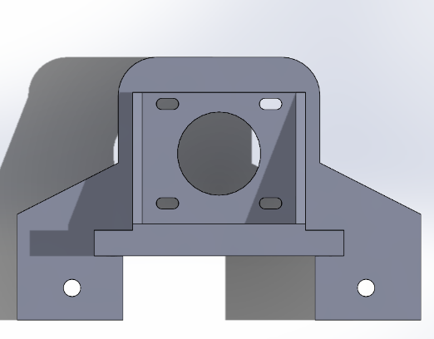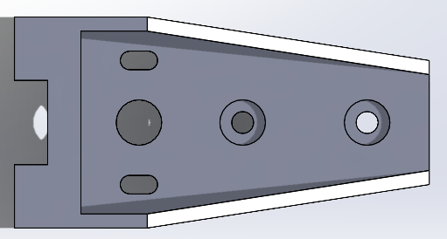

*Figure 7: z-axis assembly top view Figure: 8 lead screw bracket top view*

1. First install z-axis assembly onto the aluminum extrusions with 4 M5x10 fasteners and M5 T-nuts.
2. Attach one Nema 17 stepper motors with 4 M3x8 fasteners.
3. Connect the lead screw and the stepper motor via a coupler.
4. Connect the z axis limit switch and secure them with 2 M3x8 fasteners and 2 M3 hex nuts.
5. Attach lead screw bracket to linear rail via 4 M3x8 fasteners.
6. Attach lead screw flange to lead screw bracket via M3x12 fasteners with M3 hex nuts.
7. Adjust the XY position of lead screw with z-axis assembly and lead screw bracket flexible slots until lead screw is perpendicular to stepper motor. Turn the leadscrew until there is little resistance moving from bottom to top.

## 6.7 Electrical Assembly

### 6.8 Overview

The below diagram is a representation of the electrical components involved in this project. Since the power supply is rated at 24V and 14.6 A (Max), the voltage needs to be converted to 3 levels to accommodate CNC shield (24V), ring light (12V) and Raspberry pi (5V) respectively. Furthermore, stepper motors and limit switches (NO) are connected to CNC shield via their designated pins. An emergency stop is designed to terminate and reset the program for CNC shield. Arduino Uno is powered by the Raspberry Pi via a serial connection (USB-A to USB-B). Detail lists of Assembled List and BOM List can be found in Appendix A.6 and A.7.

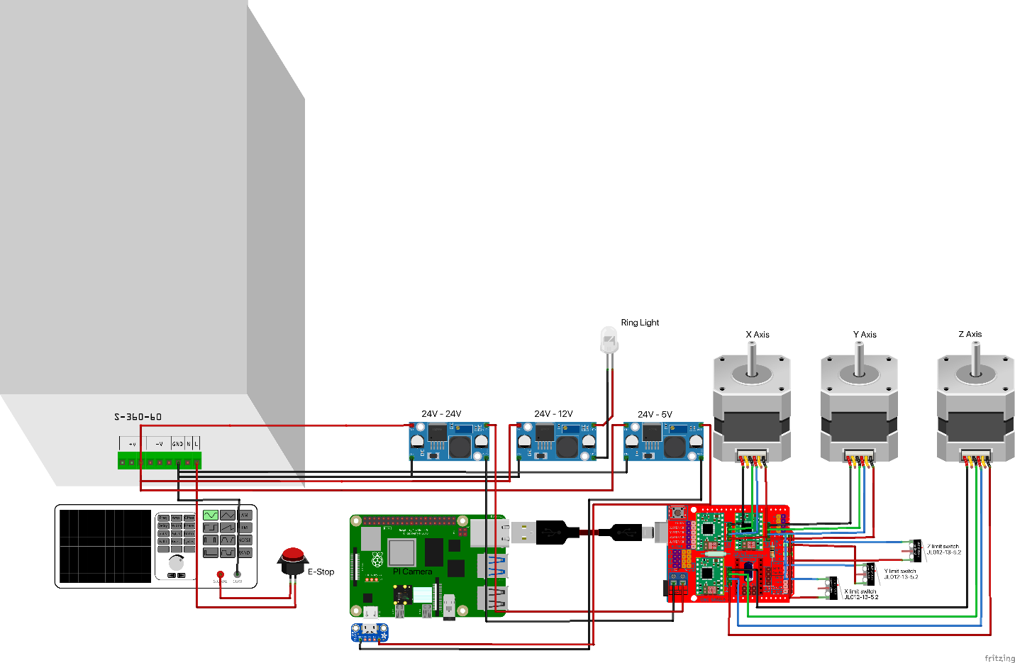

*Figure 9: Electrical components their connections*

### 6.9 E-STOP

The E-Stop is installed upstream of the DC power supply on the live wire between the fused C14 connector and the 120V input terminal of the DC power supply. Ensure ferrules are added to the wires before they are installed in the screw terminals of the E-Stop. After all electrical components are installed, the system should be ground checked before it is powered on to ensure safe operation.

### 6.10 Buck Converters

The three buck converters power the ring light, the Raspberry Pi, and the CNC shield. The input side of the buck converters should be wired in parallel to the 24V supplied by the DC power supply. For the ring light, the buck converter output should be tuned to 12V using a multimeter and then connected to a DC barrel plug. For the Raspberry Pi, the buck converter should be tuned to 5.1V and then connected to a USB-C breakout board. For the CNC shield, the buck converter should be tuned to between 15 and 24V and connected directly to the power input terminals of the CNC shield.

# 7. Software Setup

## 7.1 Raspberry Pi Settings

**Setting Up Raspberry Pi Using Raspberry Pi Imager**

Setting up the Raspberry Pi began with using the Raspberry Pi Imager tool. First, download and install Raspberry Pi Imager from the official Raspberry Pi website (https://www.raspberrypi.com/software/). Insert a microSD card or USB drive into your computer and launch the Imager. Click on "Choose OS" and select the preferred Raspberry Pi OS version. For this project, we used the default Raspberry Pi OS (64-bit). Next, click on "Choose Storage" and select the microSD card or USB drive. Next, click on the settings icon to enable SSH, set up a username and password, and configure Wi-Fi if needed. The username and password selected for this project was ‘microscope’. Once configured, click "Write" to flash the OS onto the microSD card or USB drive. After completion, eject the storage device and insert it into the Raspberry Pi. Power on the Raspberry Pi, and it will boot into the installed OS.

## 7.2 Networking

**Setting Up Static IP Addresses;**

A static IP address was configured on both the Raspberry Pi and Mini PC to establish a direct Ethernet connection between the devices. The Raspberry Pi is physically connected to the mini PC via an Ethernet cable from the Raspberry Pi’s Ethernet port to the PC’s Ethernet port.

The first step was to configure the computer’s static IP address. On Windows, navigate to the Control Panel and open the Network and Sharing Center. Click on Change adapter settings, right-click the Ethernet adapter, and select Properties. Choose Internet Protocol Version 4 (TCP/IPv4), then select ‘Use the following IP address’. Enter an IP address and set the subnet mask to 255.255.255.0. On the Mini PC used for the project, the static IP was configured to be “192.168.1.10”. Leave the default gateway blank. Click OK to save the changes.

To configure the Raspberry Pi’s static IP address, open a terminal, and type ‘ip r | grep default’ and save the gateway. Next, type ‘nmtui’ and select Edit a Connection, followed by Wired Connection. Under IPv4 Configuration, press add and enter the IP address you wish to use. For this project, we used “192.168.1.111” as our address. Also, enter the previously found gateway under Gateway. Afterward, navigate to OK at the bottom of the screen, followed by Back and Quit. Now, type ‘sudo systemctl restart NetworkManager’ into the terminal. To check if the Static IP address is working, type ‘hostname -I’ into the terminal.

Once both devices are set up, you can test the connection by opening a terminal or Command Prompt on the computer and running `ping 192.168.1.111`. A successful connection will return response packets from the Raspberry Pi.

**Remote Connection via VNC Viewer:**

To remotely access the Raspberry Pi’s desktop environment, VNC Viewer was used for this project. To enable the functionality on the Raspberry Pi, first, enable VNC by opening a terminal and running ‘sudo raspi-config’. Navigate to Interface Options, select VNC, and enable it. Then, install the RealVNC server if it is not already available using ‘sudo apt update’ and ‘sudo apt install realvnc-vnc-server’ in the terminal.

On the PC, download and install VNC Viewer from the official RealVNC website (https://www.realvnc.com/en/connect/download/viewer/). To remotely access the Raspberry Pi, open VNC Viewer and enter the VNC server ‘**bestcapstone’** with the password ‘**microscope’** if the devices are connected to the same wifi network. Otherwise, enter the Raspberry Pi’s static IP address (192.168.1.111) in the address bar with the password ‘microscope’. If prompted, enter the Raspberry Pi’s username, which is also ‘microscope’. Once connected, the Raspberry Pi’s desktop interface will be accessible remotely, allowing full control over the device without needing a monitor, keyboard, or mouse.

## 7.3 Windows PC

### 7.3.1 Ethernet

For whichever PC, ensure that it has an ethernet port, or purchase a dongle, so that it can connect to the Raspberry Pi.

### 7.3.2 Folder Directories

Setup and create folders in an organization like so, and modify gui.py (see [GitHub](https://github.com/ManuCapstone1/OpticalModule/blob/main/Programming%20Files/pc_files/gui.py)) so that it matches the folder paths you created. This structure is not essential to the program, however, ensure that you are mindful of the folder locations when making modifications to gui.py.

* images
  + GUI
  + complete
    - stitching
    - sampling
  + buffer
    - stitching
    - sampling
    - camera_tests

### 7.3.3 Fiji (ImageJ)

Download Fiji at:

<https://imagej.net/software/fiji/downloads>

**Setting up the Image Stitching Macro in Fiji (ImageJ)**

1. Record Macro

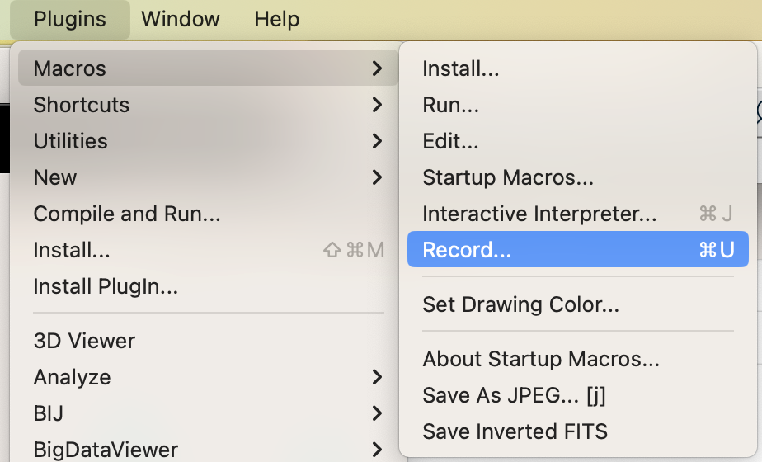

2. Image Stitching Plug in

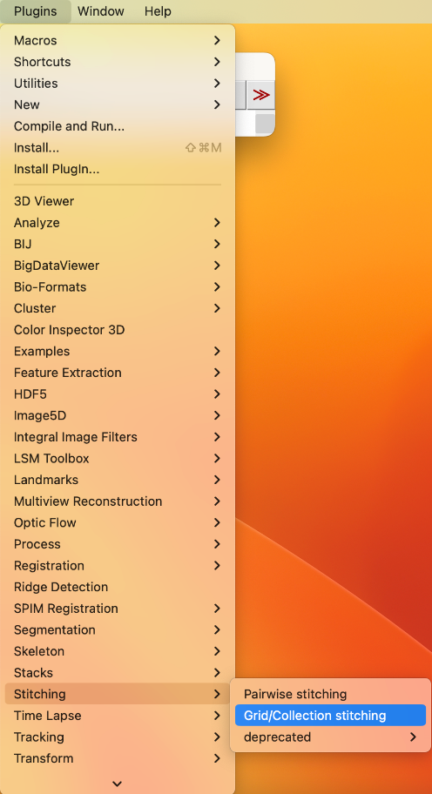

3. Configure Settings (note the Type and Order of scanning do not change)

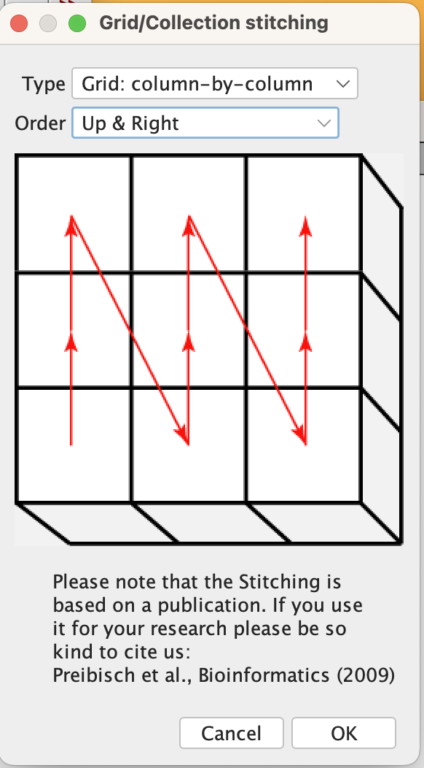

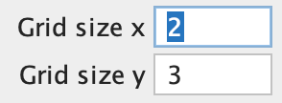



4. Run the plug-in and save the macro (.ijm file)

The macro written for this project is also available for use at this link:

<https://github.com/ManuCapstone1/OpticalModule/tree/main/Programming%20Files/fiji>

# Appendix

## A.1 – Full Parts List

Table 2: List of all parts and tools needed to build the optical module.

| Category | Part | Additional Specs or Notes | Website for Specific Parts | Needed Quantity/Size |
| --- | --- | --- | --- | --- |
| Electrical | Arduino Uno |  |  | 1 |
| Electrical | Arduino CNC Shield V3.00 | Includes 3 drivers, E-Stop pins |  | 1 |
| Electrical | Mech Endstop V1.2 with Cable |  |  | 3 |
| Electrical | E-Stop | Twist release, terminal blocks, NC. 24VDC and 10A. |  | 1 |
| Electrical | DC Power Supply | 24VDC, ~15A, 50/60Hz |  | 1 |
| Electrical | Power Inlet | 250V, 15A |  | 1 |
| Electrical | Raspberry Pi | Pi 5, RAM 2GB |  | 1 |
| Electrical | SD Card for Raspberry Pi | Class 10, 32GB or more |  | 1 |
| Electrical | Stepper Motor | NEMA 17, 1.8deg, 1A |  | 3 |
| Electrical | Stepper Motor Cables | 4 Pin, < 60cm long |  | 3 |
| Electrical | Ethernet Cable | 90 degree corner facing upwards, cable in direction of locking tab. |  | 1 |
| Electrical | USB C to USB C Cable | >40cm long |  | 1 |
| Electrical | USB C Female Breakout Board PCB | For powering Raspberry Pi from power supply. |  | 1 |
| Electrical | USB-A to USB-B Cable | > 50cm long |  | 1 |
| Electrical | USB A 90 deg corner adapter | For plugging in USB A - USB B cable into raspberry Pi |  | 1 |
| Electrical | microHDMI cable | For displaying Raspberry Pi if needed |  | 1 |
| Electrical | DC-DC Step Down Buck Converter Module | LM2596 |  | 3 |
| Electrical | 12 AWG Silicone Copper Wires | For wiring power supply to rocker. |  | >100 cm |
| Electrical | 22 AWG Solid-Core Insulated Wires | For wiring Step Down Converters |  | > 40 cm |
| Electrical | Ring Terminal Connectors |  |  | 10 |
| Electrical | Spade Terminal Connectors |  |  | 6 |
| Electrical | Cable Mesh Sleeve | >1 m, > 3/8" |  | 1 |
| Electrical | Cable Ties |  |  | ~5 |
| Electrical | PC | Ethernet Port. Interfaces with Raspberry Pi, storage for images. Runs Windows |  | 1 |
| Electrical | USB Wifi Dongle | Only if needed. To get PC Wifi. |  | 1 |
| Mechanical | Ball Screw and Nut | 150 mm long, M8, 2mm per turn | [Link](https://www.mcmaster.com/6624k67/) | 1 |
| Mechanical | Lubricant | PTFE Dry lubricant or Superlube |  | 1 |
| Mechanical | Timing Belt | GT2, 6mm |  | >2 m |
| Mechanical | Belt Pulley Toothed | GT2, 5mm bore, 6mm, toothed |  | 2 |
| Mechanical | Pulley Idler Toothed | GT2, 5mm bore, 6mm, toothed idler |  | 6 |
| Mechanical | Bearings | F695-2RS, 5x13x4mm, flanged |  | 8 |
| Mechanical | Coupler (motor to balls screw) | 5mm to 8mm |  | 1 |
| Mechanical | PLA, PLA +, ABS | Spool (1kg) |  | 2 |
| Mechanical | Linear rails X | MGN12H 300mm |  | 1 |
| Mechanical | Linear rails Y | MGN9H 350mm |  | 2 |
| Mechanical | Linear Rails Z | MGN9H 200mm |  | 3 |
| Mechanical | Spacers and Knobs for Stage | Package of 4 spacers, M4 fastener, and knobs. Typically used for 3D printers |  | 1 |
| Mechanical | Bubble gage |  |  | 1 |
| Mechanical | Leveling Feet | Adjustable height, max M6 screws, dampening | [Link](https://www.mcmaster.com/5537T982/) | 4 |
| Machined | Breadboard Stage | 150x150x13mm | [Link](https://www.aliexpress.com/item/1005006895797933.html?spm=a2g0o.productlist.main.13.38537Fk17Fk1YM&algo_pvid=284e6e19-31f7-4ceb-8cce-abef0682f1cb&algo_exp_id=284e6e19-31f7-4ceb-8cce-abef0682f1cb-6&pdp_npi=4%40dis%21CAD%2190.58%2176.99%21%21%2162.61%2153.22%21%402101c80017326288870044274e047d%2112000038646171794%21sea%21CA%216210644323%21ABX&curPageLogUid=qSWfg5B0oj7o&utparam-url=scene%3Asearch%7Cquery_from%3A) | 1 |
| Machined | Mounting plate for stage | 150x185mm, thickness 4-5mm. See engineering drawing. |  | 1 |
| Machined | Metal plate (camera carriage) | 105x80x5mm. See engineering drawing |  | 1 |
| Machined | 2020 V-Slot Aluminum Extrusion | 370mm x 11 465mm x4 395mm x1 330mm x1 255mm x1 |  | 1 |
| Optical | Camera | Raspberry Pi HQ Camera CS 12.3 MP | [Link](https://www.pishop.ca/product/raspberry-pi-hq-camera-cs/) | 1 |
| Optical | Lens | 100X Industrial Microscope Lens, C/CS-Mount, 0.12X ~ 1.8X | [Link](https://www.pishop.ca/product/100x-industrial-microscope-lens-c-cs-mount-compatible-with-raspberry-pi-hq-camera-cs/) | 1 |
| Optical | Ring Light | 62.5mm inside, 92.5mm outside diameter. | [Link](https://www.amazon.ca/Vision-Scientific-VMLIFR-09B-Adjustable-Illuminator/dp/B07VR2LJJL?pd_rd_w=ixyL5&content-id=amzn1.sym.5ea934dd-1c86-463a-87ec-1025379fbf16&pf_rd_p=5ea934dd-1c86-463a-87ec-1025379fbf16&pf_rd_r=EET0FYR75FPSX5V2ZXAY&pd_rd_wg=W6sYg&pd_rd_r=43be5ddd-b090-4223-8e1d-0ec37030dad9&pd_rd_i=B07VR2LJJL&psc=1&ref_=pd_basp_m_rpt_ba_s_1_sc) | 1 |
| Fastener | 1/4" Washer |  |  | 2 |
| Fastener | 1/4-20 x 1/2" BHCP or SHCP |  |  | 1 |
| Fastener | 2020 Corner Bracket |  |  | 34 |
| Fastener | M2.5 Hex Nut |  |  | 20 |
| Fastener | M2.5x14 BHCP or SHCP |  |  | 16 |
| Fastener | M2.5x16 FHCP |  |  | 4 |
| Fastener | M3 Drop T-nut |  |  | 34 |
| Fastener | M3 Hex Nut |  |  | 10 |
| Fastener | M3x4 BHCP or SHCP |  |  | 4 |
| Fastener | M3x8 BHCP or SHCP |  |  | 16 |
| Fastener | M3x8 SHCP |  |  | 34 |
| Fastener | M3x12 BHCP or SHCP |  |  | 18 |
| Fastener | M3x16 BHCP or SHCP |  |  | 4 |
| Fastener | M3x30 BHCP or SHCP |  |  | 4 |
| Fastener | M4 Hex Nut |  |  | 2 |
| Fastener | M4x8 BHCP or SHCP |  |  | 2 |
| Fastener | M4x14 BHCP or SHCP |  |  | 2 |
| Fastener | M4x20 BHCP or SHCP |  |  | 2 |
| Fastener | M5 Drop T-Nut |  |  | 168 |
| Fastener | M5 Hex Nut |  |  | 12 |
| Fastener | M5 Washers |  |  | 74 |
| Fastener | M5x10 BHCP |  |  | 168 |
| Fastener | M5x40 BHCP or SHCP |  |  | 2 |
| Fastener | M5x40 SHCP |  |  | 8 |
| Fastener | M5x45 BHCP or SHCP |  |  | 1 |
| Fastener | M6x14 BHCP or SHCP |  |  | 2 |
| 3D Printed | Enclosure Base V2 |  |  | 1 |
| 3D Printed | Enclosure Cover Front |  |  | 1 |
| 3D Printed | Enclosure Cover Upper |  |  | 1 |
| 3D Printed | Belt Adapter |  |  | 1 |
| 3D Printed | Idler Mount B | No limit switch mount. |  | 1 |
| 3D Printed | Idler Mount A | Includes limit switch mount. |  | 1 |
| 3D Printed | XY Motor Mount | One as is, the other mirrored |  | 2 |
| 3D Printed | Z Carriage | One as is, the other mirrored |  | 2 |
| 3D Printed | Ball Screw Bracket |  |  | 1 |
| 3D Printed | Z Motor Bracket |  |  | 1 |
| 3D Printed | Housing Base |  |  | 1 |
| 3D Printed | Housing Top |  |  | 1 |
| 3D Printed | Belt Tensioner |  |  | 1 |
| 3D Printed | estop enclosure bottom |  |  | 1 |
| 3D Printed | estop enclosure top |  |  | 1 |
| 3D Printed | Power Supply Housing |  |  | 1 |
| 3D Printed | Sample Holder Pin | Add a spring from a pen to the cylindrical part of the pin. |  | 1 |
| 3D Printed | Sample holder clamping plate |  |  | 1 |
| 3D Printed | Sample holder base |  |  | 1 |
| 3D Printed | Left Y Carriage Top |  | [GitHub rolohuan](https://github.com/rolohaun/SimpleCore/tree/main/CAD) | 1 |
| 3D Printed | Left Y Carriage Bottom |  | [GitHub rolohuan](https://github.com/rolohaun/SimpleCore/tree/main/CAD) | 1 |
| 3D Printed | Right Y Carriage Top |  | [GitHub rolohuan](https://github.com/rolohaun/SimpleCore/tree/main/CAD) | 1 |
| 3D Printed | Right Y Carriage Bottom |  | [GitHub rolohuan](https://github.com/rolohaun/SimpleCore/tree/main/CAD) | 1 |
| 3D Printed | X Limit Switch Mount |  |  | 1 |
| 3D Printed | MGN9 Linear Rail Jig | Print at standard/weaker settings. | [Thingiverse](https://www.thingiverse.com/thing:5903898/files) | 2 |
| 3D Printed | MGN12 Linear Rail Jig | Print at standard/weaker settings. | [Thingiverse](https://www.thingiverse.com/thing:5903898/files) | 2 |
| 3D Printed | T-bracket |  | [Thingiverse](https://www.thingiverse.com/thing:2503622/files) | 4 |
| 3D Printed | Top Corner Bracket |  | [Thingiverse](https://www.thingiverse.com/thing:2655498) | 4 |
| 3D Printed | Ball Screw Knob | Scaled at 97% | [Thingiverse](https://www.thingiverse.com/thing:3014508/files) | 1 |
| 3D Printed | Cable Management Clips |  | [Thingiverse](https://www.thingiverse.com/thing:4612080/files) | ~20 |
| Tools | Metric Allen Keys |  |  | 1 |
| Tools | Wire Cutter |  |  | 1 |
| Tools | Crimping Tool |  |  | 1 |
| Tools | Soldering Iron |  |  | 1 |
| Machining Tools | Band Saw | If needed, for cutting extrusions. |  |  |
| Machining Tools | Milling Machine | If needed, for cutting extrusions. |  |  |
| Machining Tools | Power Drill | If needed, for tapping holes for extrusion leveling feet. |  |  |
| Machining Tools | Tap and Drill for M6 Holes | If needed, for cutting mounting plate. |  |  |
| Machining Tools | Waterjet Cutter |  |  |  |

## A.2 – List of Fasteners per Part

Table 3 - List of fasteners corresponding to each part.

| Row Labels | Sum of # Parts | Sum of Total |
| --- | --- | --- |
| **Ball Screw Bracket** | **5** | **20** |
| M3x8 BHCP or SHCP | 1 | 4 |
| M4 Hex Nut | 1 | 2 |
| M4x14 BHCP or SHCP | 1 | 2 |
| M5 Drop T-Nut | 1 | 6 |
| M5x10 BHCP | 1 | 6 |
| **Belt Tensioner** | **4** | **5** |
| M5 Drop T-Nut | 1 | 1 |
| M5 Hex Nut | 1 | 2 |
| M5x10 BHCP | 1 | 1 |
| M5x45 BHCP or SHCP | 1 | 1 |
| **Enclosure Base** | **5** | **15** |
| 1/4" Washer | 1 | 2 |
| 1/4-20 x 1/2" BHCP or SHCP | 1 | 1 |
| M3 Hex Nut | 1 | 4 |
| M3x4 BHCP or SHCP | 1 | 4 |
| M3x8 BHCP or SHCP | 1 | 4 |
| **Enclosure Cover Upper** | **2** | **8** |
| M2.5 Hex Nut | 1 | 4 |
| M2.5x16 FHCP | 1 | 4 |
| **E-Stop Housing** | **2** | **4** |
| M5 Drop T-Nut | 1 | 2 |
| M5x10 BHCP | 1 | 2 |
| **Frame** | **4** | **238** |
| 2020 Corner Bracket | 1 | 34 |
| M5 Drop T-Nut | 1 | 68 |
| M5 Washers | 1 | 68 |
| M5x10 BHCP | 1 | 68 |
| **Housing Base** | **2** | **32** |
| M2.5 Hex Nut | 1 | 16 |
| M2.5x14 BHCP or SHCP | 1 | 16 |
| **Housing Top** | **2** | **6** |
| M5 Drop T-Nut | 1 | 3 |
| M5x10 BHCP | 1 | 3 |
| **Idler Mount A** | **6** | **10** |
| M3 Hex Nut | 1 | 2 |
| M3x16 BHCP or SHCP | 1 | 2 |
| M5 Drop T-Nut | 1 | 2 |
| M5 Hex Nut | 1 | 1 |
| M5x10 BHCP | 1 | 2 |
| M5x40 BHCP or SHCP | 1 | 1 |
| **Idler Mount B** | **4** | **6** |
| M5 Drop T-Nut | 1 | 2 |
| M5 Hex Nut | 1 | 1 |
| M5x10 BHCP | 1 | 2 |
| M5x40 BHCP or SHCP | 1 | 1 |
| **Left Y Carriage** | **6** | **18** |
| M3x12 BHCP or SHCP | 1 | 2 |
| M3x30 BHCP or SHCP | 1 | 2 |
| M5 Drop T-Nut | 1 | 3 |
| M5 Hex Nut | 1 | 4 |
| M5x10 BHCP | 1 | 3 |
| M5x40 SHCP | 1 | 4 |
| **Linear Rail X** | **2** | **10** |
| M3 Drop T-nut | 1 | 5 |
| M3x8 SHCP | 1 | 5 |
| **Linear Rail Y** | **4** | **28** |
| M3 Drop T-nut | 2 | 14 |
| M3x8 SHCP | 2 | 14 |
| **Linear Rail Z** | **6** | **30** |
| M3 Drop T-nut | 3 | 15 |
| M3x8 SHCP | 3 | 15 |
| **Mounting plate for stage** | **3** | **18** |
| M5 Drop T-Nut | 1 | 6 |
| M5 Washers | 1 | 6 |
| M5x10 BHCP | 1 | 6 |
| **Power Supply Housing** | **2** | **4** |
| M4x8 BHCP or SHCP | 1 | 2 |
| M4x20 BHCP or SHCP | 1 | 2 |
| **Right Y Carriage** | **6** | **18** |
| M3x12 BHCP or SHCP | 1 | 2 |
| M3x30 BHCP or SHCP | 1 | 2 |
| M5 Drop T-Nut | 1 | 3 |
| M5 Hex Nut | 1 | 4 |
| M5x10 BHCP | 1 | 3 |
| M5x40 SHCP | 1 | 4 |
| **Sample Holder** | **1** | **2** |
| M6x14 BHCP or SHCP | 1 | 2 |
| **T-Bracket** | **8** | **40** |
| M5 Drop T-Nut | 4 | 20 |
| M5x10 BHCP | 4 | 20 |
| **Top Corner Bracket** | **8** | **72** |
| M5 Drop T-Nut | 4 | 36 |
| M5x10 BHCP | 4 | 36 |
| **X Limit Switch Mount** | **4** | **8** |
| M3 Hex Nut | 1 | 2 |
| M3x16 BHCP or SHCP | 1 | 2 |
| M5 Drop T-Nut | 1 | 2 |
| M5x10 BHCP | 1 | 2 |
| **XY Motor Mount** | **6** | **20** |
| M3x8 BHCP or SHCP | 2 | 8 |
| M5 Drop T-Nut | 2 | 6 |
| M5x10 BHCP | 2 | 6 |
| **Z Carriage** | **6** | **16** |
| M3x12 BHCP or SHCP | 2 | 8 |
| M5 Drop T-Nut | 2 | 4 |
| M5x10 BHCP | 2 | 4 |
| **Z Motor Bracket** | **4** | **16** |
| M3 Hex Nut | 1 | 2 |
| M3x12 BHCP or SHCP | 1 | 6 |
| M5 Drop T-Nut | 1 | 4 |
| M5x10 BHCP | 1 | 4 |
| **Total** | **NA** | **644** |

## A.3 – List of Machined Parts

Table 4: List of parts that need to be machined and links to their instructions.

|  |  |  |
| --- | --- | --- |
| Part | Engineering Drawing | Link to Instructions |
| Supporting Platform | [CAD/Engineering Drawings/supporting platform.pdf](https://github.com/ManuCapstone1/OpticalModule/blob/main/CAD/Engineering%20Drawings/supporting%20platform.pdf) | Plates |
| Breadboard Platform | [CAD/Engineering Drawings/breadboard platform.pdf](https://ubcca.sharepoint.com/teams/ubcst-gr-MANU430SelfDrivingMaterialsCharacterization/Shared%20Documents/General/Deliverables/CAD/Engineering%20Drawings/breadboard%20platform.pdf) | Plates |
| 2020 V-Slot Aluminum Extrusions (Frame) | [CAD/Engineering Drawings/430 Main project assy.pdf](https://github.com/ManuCapstone1/OpticalModule/blob/main/CAD/Engineering%20Drawings/430%20Main%20project%20assy.pdf) | Frame |
| Enclosure Backplate | [CAD/Engineering Drawings/Enclosure Backplate.pdf](https://github.com/ManuCapstone1/OpticalModule/blob/main/CAD/Engineering%20Drawings/Enclosure%20Backplate.pdf) | Plates |

## A.4 – Assembly List - Electronics

Table 5: List of parts that need to be assembled for electronics

|  |  |  |
| --- | --- | --- |
| Label | Part Type | Properties |
| 24V - 12V | LM2596 step down module | type LM2596 step down |
| 24V - 24V | LM2596 step down module | type LM2596 step down |
| 24V - 5V | LM2596 step down module | type LM2596 step down |
| A1 | Raspberry Pi 5 | processor Broadcom 2711, Quad-core Cortex-A76 64-bit SoC @ 2.4GHz; variant Raspberry Pi 5 |
| Arduino CNC Shield V3.00 1 | Arduino_CNC_V3.00 | variant variant 2 |
| Part1 | Arduino Uno (Rev3) | type Arduino UNO (Rev3) |
| Part2 | Adafruit Micro USB Breakout | variant variant 2; part # Adafruit #1833 |
| PI Camera | IC | chip label IC; editable pin labels false; hole size 1.0mm,0.508mm; package DIP (Dual Inline) [THT]; pin spacing 300mil; pins 8; variant variant 6 |
| Power Supply | DC Power Supply | internal resistance 0Ω; max current 14.6A; type dc; voltage 24V |
| Ring Light | LEDs | package led10mm; variant variant 1 |
| USBTTL1 | USB A Plug | variant 1 |
| USBTTL2 | USB B Plug | variant 2 |
| X Axis | Stepper Motor - Unipolar | stepper type Unipolar |
| X limit switch | JL012-13-5.2 Lever (Limit) Switch SPDT + NO + NC | variant mini; part # JL012-13-5.2 |
| Y Axis | Stepper Motor - Unipolar | stepper type Unipolar |
| Y limit switch | JL012-13-5.2 Lever (Limit) Switch SPDT + NO + NC | variant mini; part # JL012-13-5.2 |
| Z Axis | Stepper Motor - Unipolar | stepper type Unipolar |
| Z limit switch | JL012-13-5.2 Lever (Limit) Switch SPDT + NO + NC | variant mini; part # JL012-13-5.2 |

## A.5 – BOM - Electronics

Table 8: Bill of Materials for electronics

|  |  |  |
| --- | --- | --- |
| Part Type | Properties | Amount |
| LM2596 step down module | Type LM2596 step down | 3 |
| Raspberry Pi 5 | Processor Broadcom 2711, Quad-core Cortex-A76 64-bit SoC @ 2.4GHz; variant Raspberry Pi 5 | 1 |
| Arduino_CNC_V3.00 | Variant 2 | 1 |
| Arduino Uno (Rev3) | Type Arduino UNO (Rev3) | 1 |
| Adafruit Micro USB Breakout | Variant 2; part # Adafruit #1833 | 1 |
| Pi Camera | Chip label IC; editable pin labels false; hole size 1.0mm,0.508mm; package DIP (Dual Inline) [THT]; pin spacing 300mil; pins 8; variant 6 | 1 |
| DC Power Supply | Internal resistance 0Ω; max current 14.6A; type dc; voltage 24V | 1 |
| LEDs | Package led10mm; variant variant 1 | 1 |
| USB A Plug | Variant 1 | 1 |
| Micro USB B Plug | Variant 2 | 1 |
| Stepper Motor - Unipolar | Stepper type Unipolar | 3 |
| JL012-13-5.2 Lever (Limit) Switch SPDT + NO + NC | Variant mini; part # JL012-13-5.2 | 3 |